Intelligence Inference Engine

User Guide

Table of Contents
Table of Contents
Table of Contents 2
Opening Remarks (Learning by Example) 3
Prefix List (shortcode : definition) 3
Front Page 5
Database Explorer Page 6
Search Page 7
Submission Page 12
Advanced Feature: Bulk Export / Bulk Import 14
Advanced Feature: Custom Query 17
Closing Remarks 18

Opening Remarks (Learning by Example)

Good day, welcome to the user guide for the Intelligence Inference Engine. This opening remarks section will act as a simple tutorial to understand the basics behind the Relational Database Format and how to best utilize our system.

First, let's begin by highlighting each of the elements and explaining what they mean.

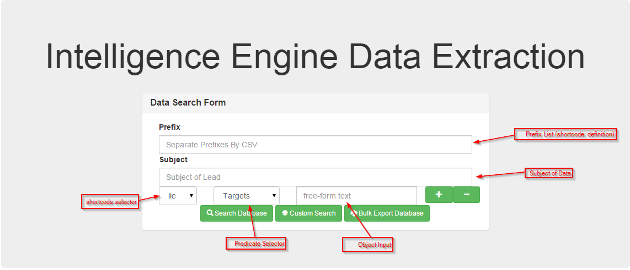

In order for fully understand RDF, you must understand how it is composed.
The most basic composition (triple-store) is composed of a Subject, a Predicate, and an Object.
- Subject – A specific item (Ex: Apple)
- Predicate – A specific action (Ex: Created)
- Object – Another specific item (Ex: iPhone)

When you combine all three, you get a very simple relation (“Apple Created iPhone”)
This is the overall purpose of RDF, to illustrate information by relations.
Let's now look at how some the UI elements are used to make inputting and searching data easier.

Prefix List (shortcode : definition)
Prefixes are used in order to make SPARQL queries more readable by human users. An example of this would our custom prefix iie. The short code iie actually replaces part of our predicates full definition, which is <fake/iie/types/(predicate_name)>
Let's try to define a simple relation (“Windows runs on Desktop PC”)
For this kind of a relation, one would utilize a new prefix and a new predicate (runs_on), for example.
Let's see how we can do this in pictures and go through each of the data fields that is being created.

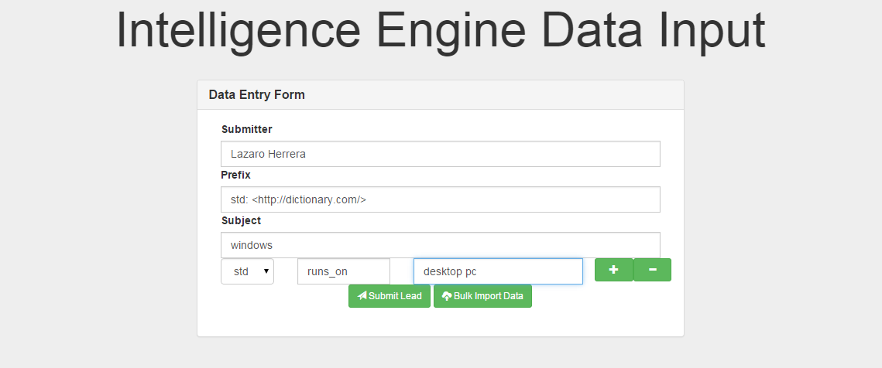
Submitter: Lazaro Herrera (this is the person's name who is submitting the data)
Prefix: std: <http://dictionary.com/>
- Here we've defined a “shortcode” called “std” for “standard”
- We have also defined a “data source” which can further define our predicates
Subject: windows
- Here we have our subject as “windows”
Shortcode Selector: std
- Here we link this next data “object” to the “std” prefix.
Predicate: runs_on
- Here we have defined our own predicate (the default list is useful but limited)
Object Input: desktop pc
- Here we can enter the element that is related to the other one.
We could now submit this data element to the Database Entry page.
We hope this small tutorial helps you better understand how to utilize our system and that you continue on to learn about all of the features that are available within our system.

Front Page

Welcome to the front page of the Intelligence Inference Engine.
From here, you can easily contribute data to our database, search for data from our database or view our current database in it's graphical format.
Click on either the headings or the buttons on the page to begin using the Intelligence Inference Engine.
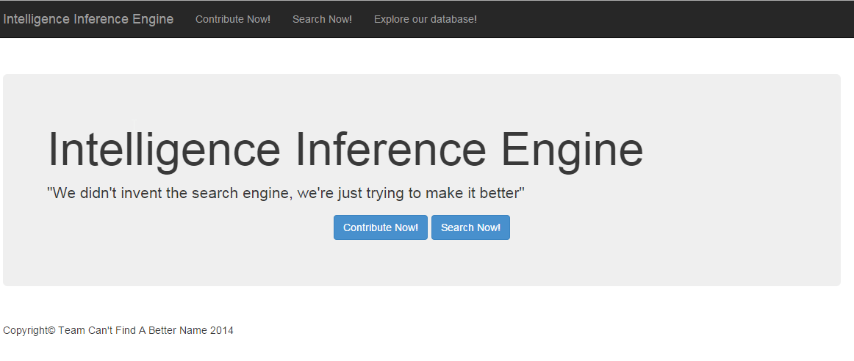

Database Explorer Page

Below is a picture of the Database Exploration page. It is a fully graphical interface that can be used to see every fact currently created within our database.
As more and more data is added, connections can be automatically displayed from data entered.

For example:
The answer to “What is the connection between ATT and Google?” is rather simple.
Answer: “ATT is a telecommunications company that sells mobile devices that may contain the android operating system that is created by Google”
The astounding fact is that all of these data facts were created with two-three operations without ever having to write any code in the RDF query language (SPARQL)
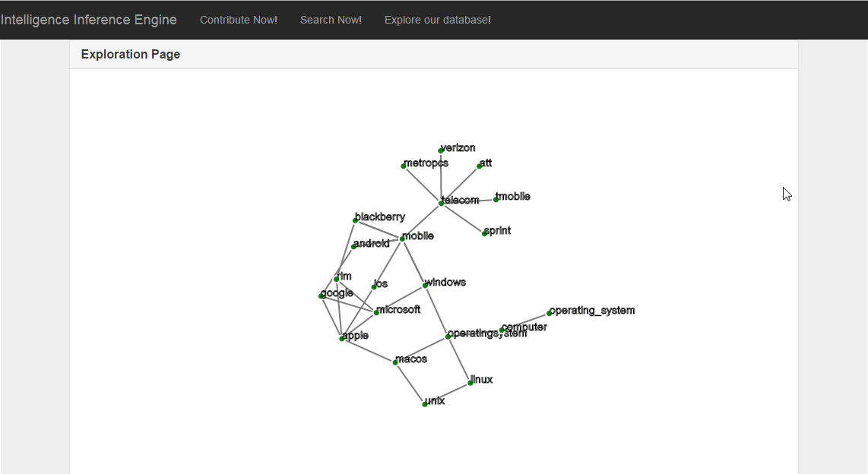

Search Page

Here is the search page for the Intelligence Inference Engine.
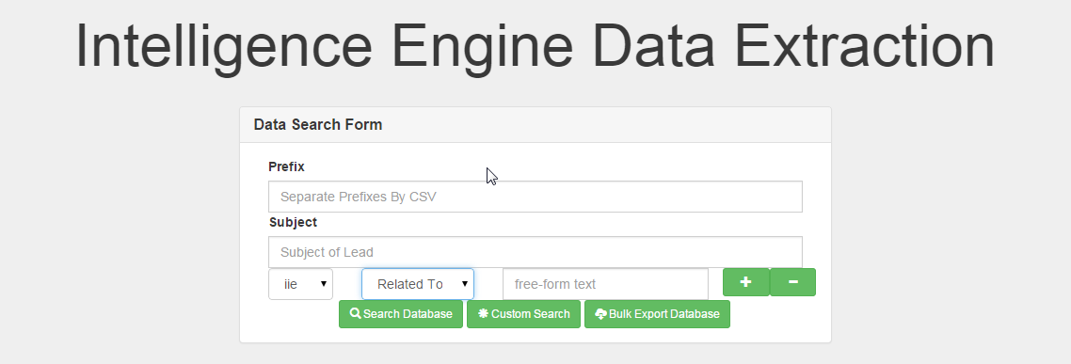
When using this webpage, please remember that anything left empty is being searched for.
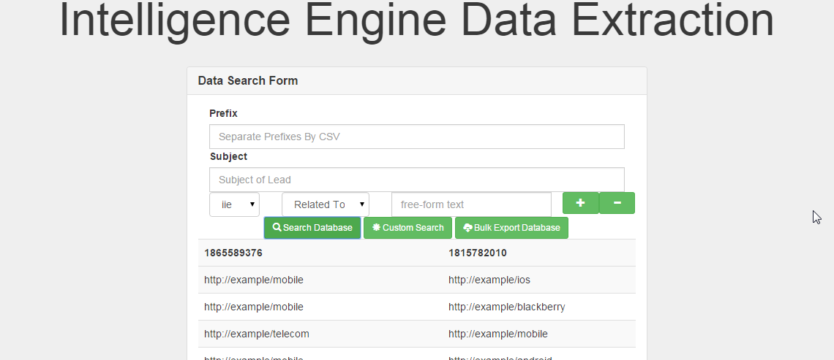
First, let's look at the most basic of searches (search for anything related to anything else).
As you can see, we merely changed the predicate to “Related To” and hit “Search Database”
This search returned anything that was “related to” anything else.
Let's try refining our search a bit further by searching for only items that are related to “mobile”.
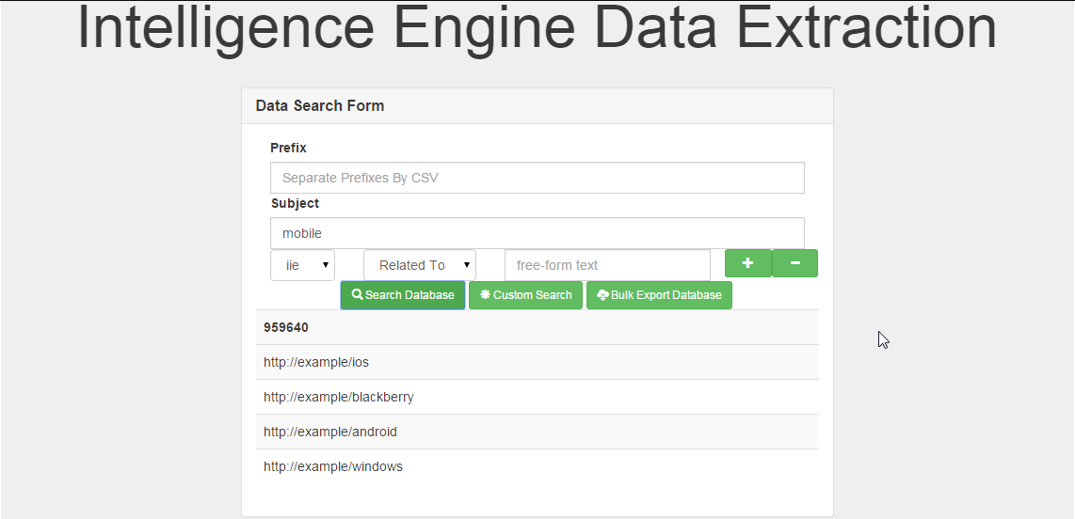
By adding mobile as a subject, we now get the items that are related to mobile.
Now let's try something more interesting, how about searching for the relation between mobile and android?
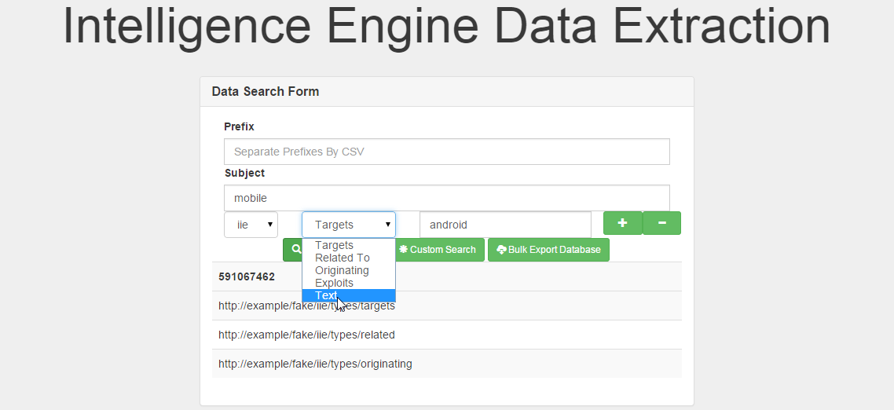
First, enter “android” in the object text box and then use the predicate selector to Text.
This should allow you to enter a custom prefix/predicate.
We are not going to enter anything, instead, we are simply going to search.
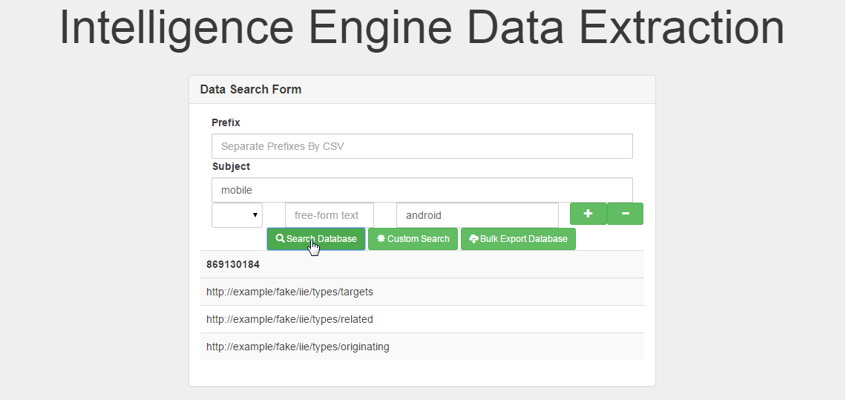
Now we can see that there are three relations that bind these items together.

Now let's try something more interesting.
The modular web form actually allows for additional objects to be tied together.
For example, click on the + button once and let's create two more element searches.
Tip: You can enter “drop!” on a free-form predicate text box to turn it into a drop down.

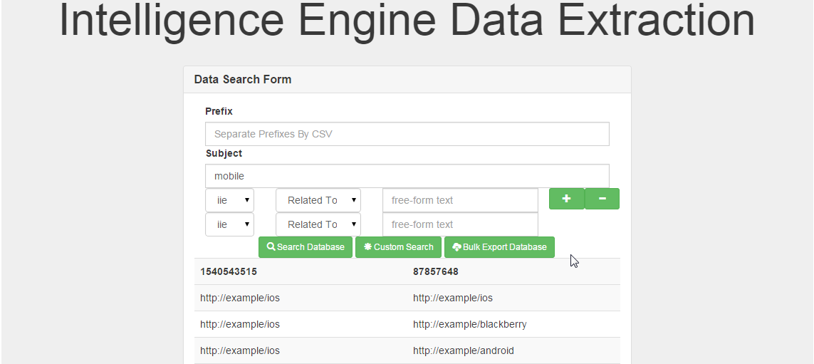
Wanna guess what we searched for?
Answer: We are searching for any element that is related to mobile that is also related to some other element. You can see that the first three results (ios → ios, ios → blackberry, ios → android) are very good examples of how this relation can be used in the field.

For the next few sections, we'll talk about some of the enhancements that exist in the search page.

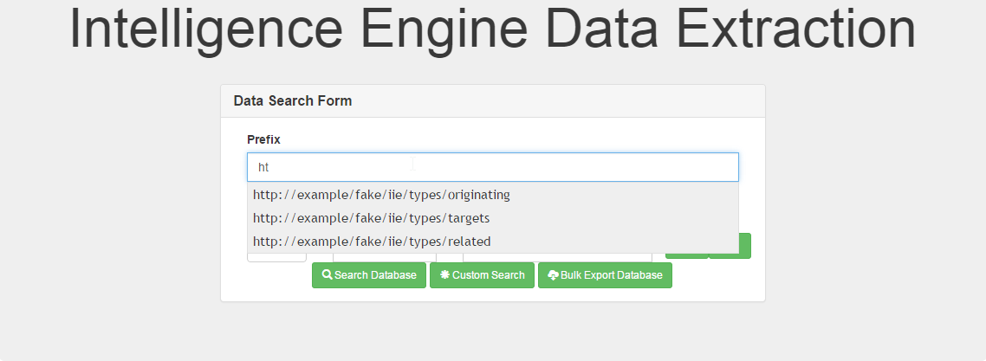
The previous is an example of the prefix historical autocomplete.
All dictionary definitions in the database are available here.

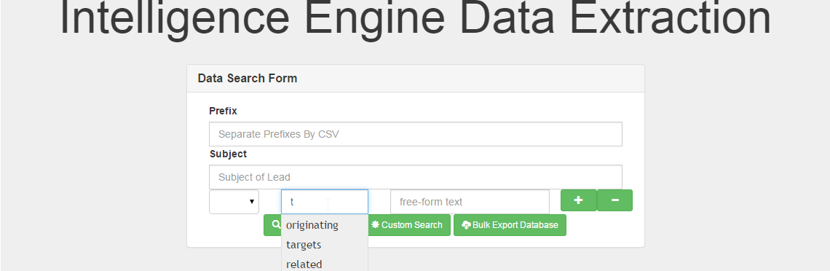
The previous is an example of the predicate historical autocomplete.
All predicate definitions in the database are available here.

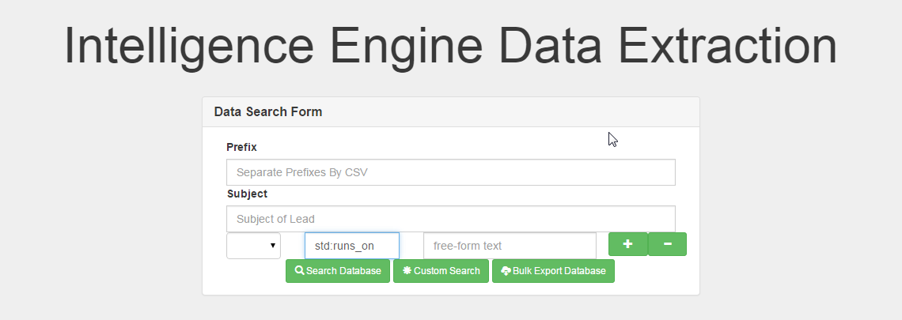
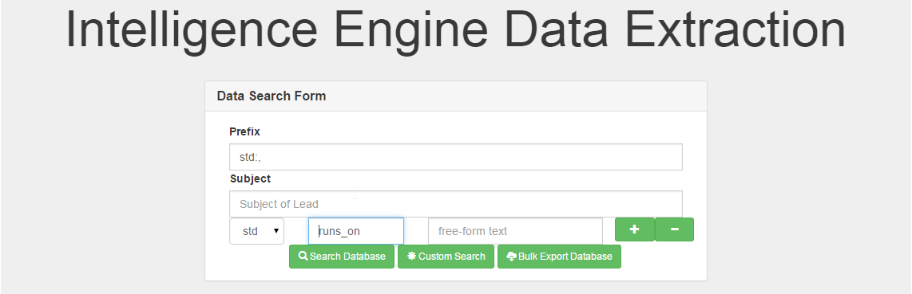
The previous is an example of prefix : predicate quick typing.
This allows you to define a new prefix : predicate pair as you go.

Submission Page

Here is the submission page for the Intelligence Inference Engine.
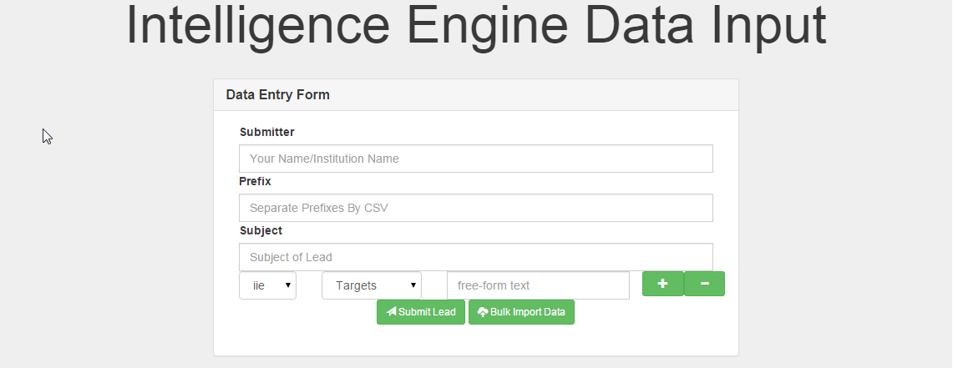
Most of the knowledge from the tutorial and the Search Page actually applies here except with two additional items.

The first item is the inclusion of a “Submitter” field. This is a mandatory field as it allows us to keep track of the top collaborators and rank the best submitters of data.

The second item is the inclusion of an “Evidence Evaluation” system. We will illustrate it's use below.
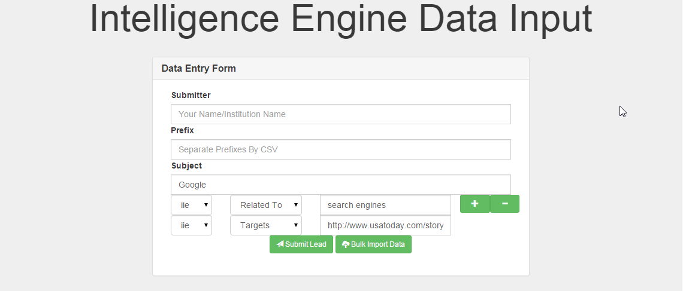
First, we add the data to show that “google” is “related to” “search engines”, then we add an article (http://www.usatoday.com/story/tech/2014/12/06/ozy-santa-google-search-engine/19965645/) that can be used as evidence.
Then we change the “targets” to “evidence” on the article in order for evidence evaluation to kick in.

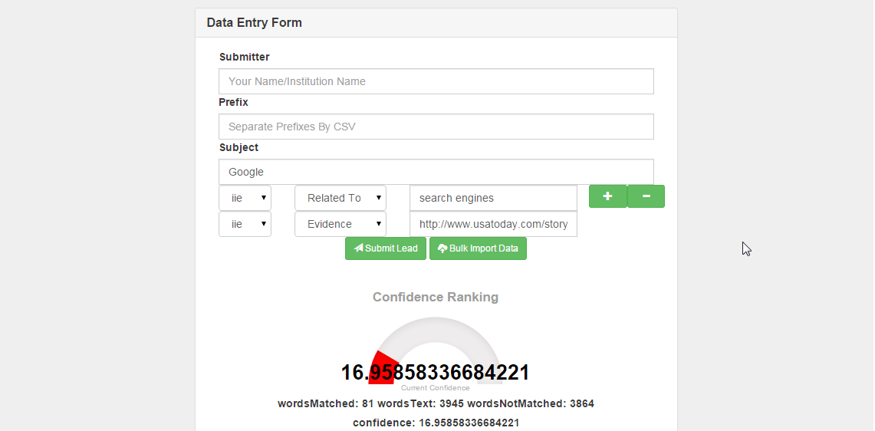

The evidence evaluation module is designed to give a number to the data that is entered in regards to other articles from the web.

Advanced Feature: Bulk Export / Bulk Import

When looking at the search/submit page, you may see that there is much more than just “Search Database” and “Submit Lead”. These advanced features may help you get the most out of the Intelligence Inference Engine so they are documented here.
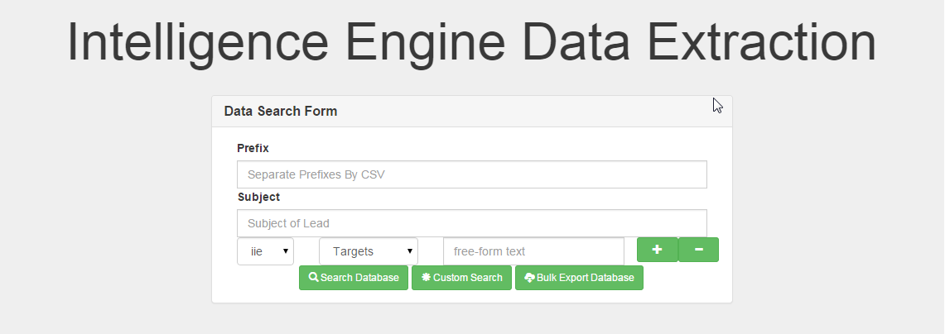
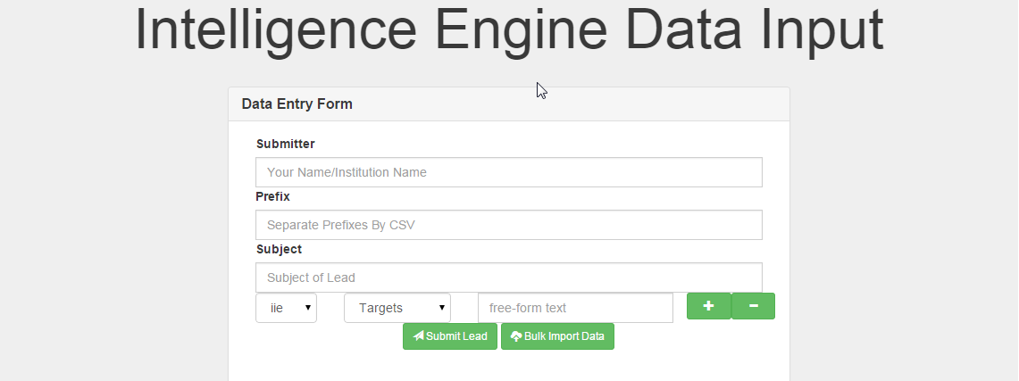

One of the features looking towards the future are the Bulk Export/ Bulk Import combination features.

Clicking the Bulk Export will generate a full XML file with all the data current existing in the RDF database. This feature is great for setting up redundant databases, or even allowing information to flow more freely among multiple systems.
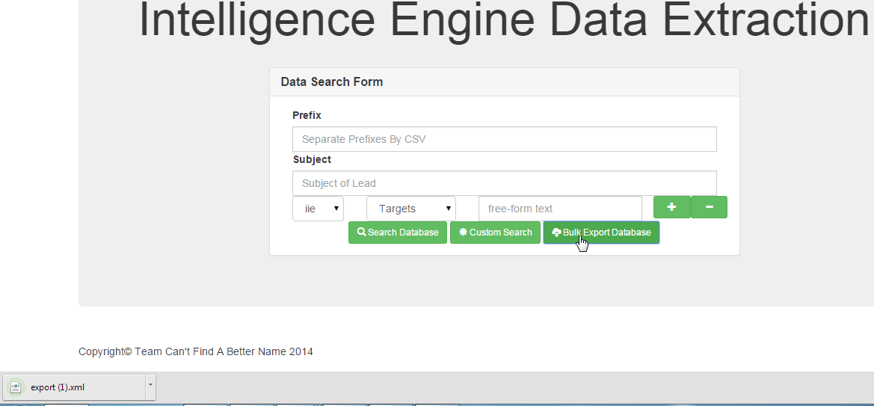

Alternatively, on the Submit Page, clicking the “Bulk Import Data” button will allow you to import an XML file into our database.
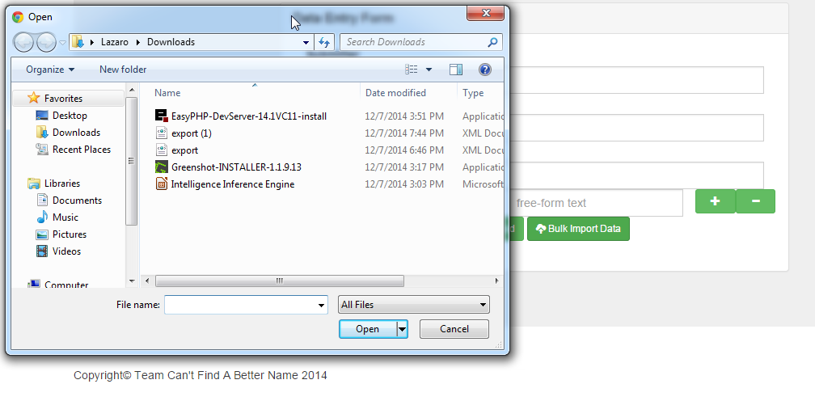
Select a file to begin importing data and you will be notified of how many records succeeded/failed.
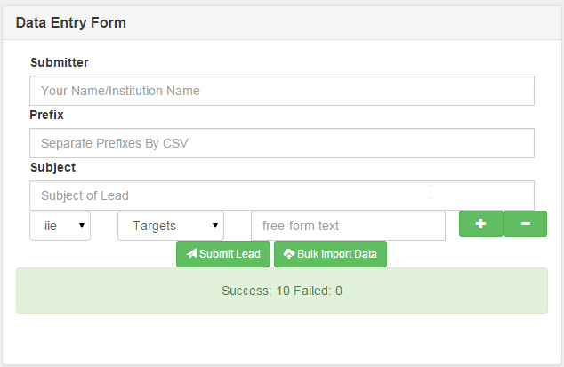
For example, this file with 32 records takes 5 seconds to import instead of having to use the import form.

The format for the XML file is the same as the output of the Bulk Exporter.

Advanced Feature: Custom Query

Feeling limited by the simplicity? Don't worry, we felt the same way. This is the reason we created the Custom Query system. Along with being able to execute raw SPARQL for searching, we allow you to store and retrieve your queries.

Clicking on the “Custom Search” button from the Search Page will bring you here.
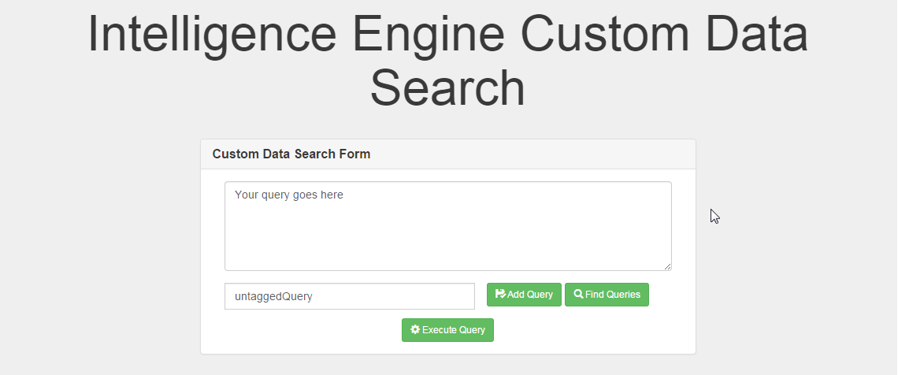

Enter a valid SPARQL query and a tag, then click “Add Query” to store your query for later use.
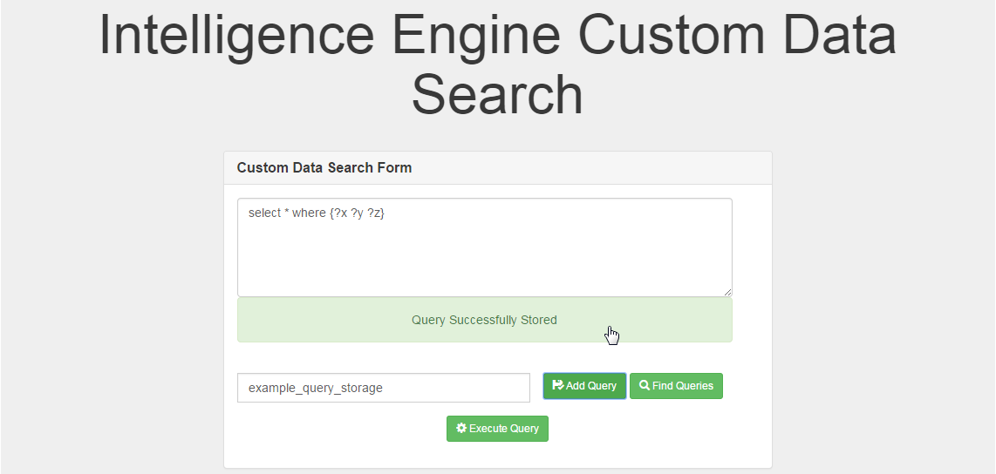
Enter your tags and press “Find Queries” to retrieve all SPARQL queries stored under that tag.
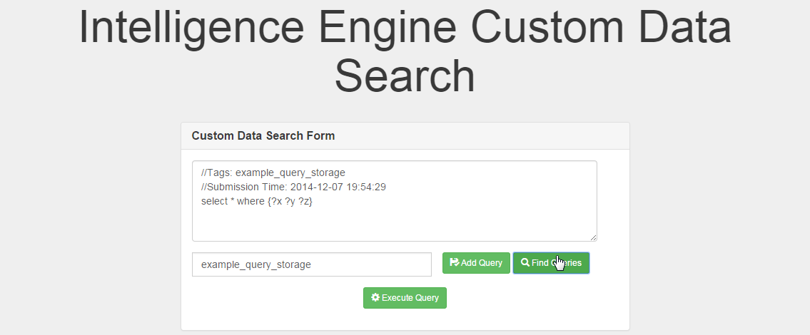
When ready, you can press “Execute Query” to get data directly from the database.
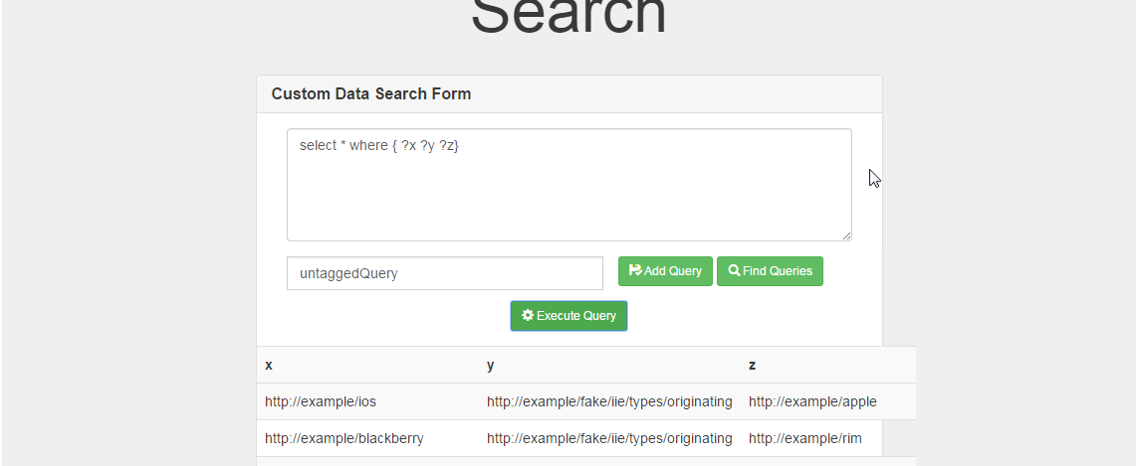

Closing Remarks

Congratulations, you have completed the User Guide for the Intelligence Inference Engine. We hope this conveys our vision for the product and allowed you to learn some information regarding the Semantic Web and Relational Databases and how they can be applied to Searching for data.

